Jennifer MacKenzie
Centralia, WA | 360-559-3269 | mackenziesbox@gmail.com

October 8, 2019
To whom it may concern;
I would like to compete for the Buyer (purchasing and procurement) position within your company. I work well with all people and I am a natural leader. I have over 22 years’ experience in customer service, office administration, inventory management both stock and special order. In my most recent WSDOT role as a Fiscal Tech 3, after promoting from at Fiscal tech 2 and secretary senior, I have successfully provided support services to the signal maintenance and ITS teams as well as back up for my prior position within the traffic office, serving as support for the maintenance and traffic design and operations teams there.
Skills I possess that would benefit your company includes but is not limited to, inventory, purchasing and procurement. Buying product and services, reviewing contracts and project management. I have experience with a multitude of agencies, working with interoffice needs, including cities, counties, the Washington State Patrol, maintenance, Police Departments and Sheriff’s offices. and personnel management, accounting functions to encompass payroll entry, and customer service roles, answering questions about time sheets, leave, pay, union rules. Calendar management, Travel booking, per Diem reimbursement. I have experience creating and editing documents. I have experience in assisting both internal and external clients with various needs, while maintaining the integrity of the agency that I work for. I love helping people find what they need and solving issues. If I don’t know it, I find the answer. I have management experience, I was a train the trainer for Washington State agency for the new state time keeping system. I process accounts payable and receivable, manage general accounting functions, fiscal analysis and purchasing. I am proficient with many software programs, both mainstream, government agency and proprietary. Being a professional that is well organized, intuitive, and proactive allows me the abilities to multi task efficiently and have a strong attention to detail. I also have experience finding documents on the odyssey portal. I am familiar with court procedure, etiquette and forms. I’m experienced with completing tasks in a fast paced and high stress environment while maintaining a positive attitude.
I hold an Associate’s degree equivalent and I have 6 remaining credits before I have completed my bachelor’s degree. I learn new programs and environments quickly. I have a good understanding buying, inventory, parts, and management and would serve your company well.
I look forward to discussing this position with you.
Sincerely,
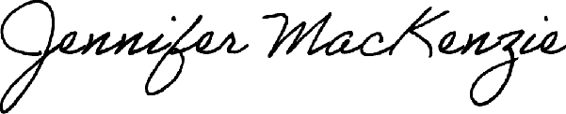
Jennifer MacKenzie

