Clarence Harrison
| (435)299-2513 | clarenceharrison@live.com
September 30, 2019
Braun NW Inc.
150 North Star Drive
Chehalis, WA 98532
Good day:
I am excited to be writing to you and the team at Braun NW Inc. to express my interest in the open position of Buyer.
I believe myself to be a competitive candidate for this position because of my 10+ years of efficient / cost effective procurement and an above average understanding of supply chain operations. This skillset comes from a background in federal procurement as an active duty service member using methods including, internal requisitions/transfers, open market purchases using purchase card, and ordering against existing contracts. I possess a strong working knowledge of material requirements planning and supply management systems and I am able to perform and contribute to team success in a variety of demanding and high stress environments.
After separation from active duty and while growing my skillset as a purchaser, I broadened my professional knowledge with a firm grasp on LEAN/Six Sigma and project management principals and methodologies.
I would be delighted to have the opportunity to discuss my qualifications in person with you and the team at at Braun NW. Thank you again for you time.

Sincerely,
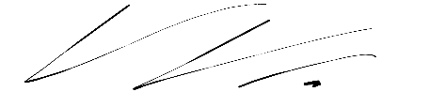
Clarence Harrison

